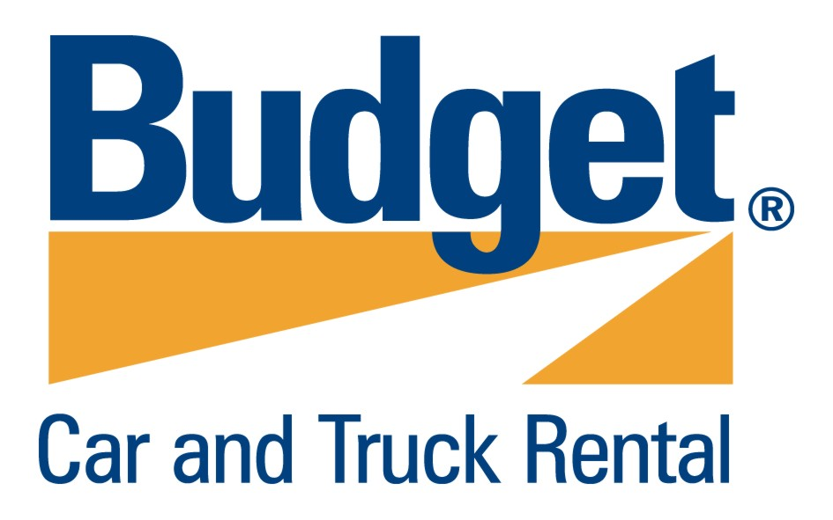
Budget DELEGATES RATES

PASSENGER VEHICLE METRO & COUNTRY Rate Schedule

Passenger Vehicles
Vehicle Group | Vehicle Type | Daily Rate | Weekly Rate | Monthly Rate
A | Compact Manual Hyundai Accent (3 Door) or Similar | $ 51.96 | $ 40.83 | $ 38.10
B | Compact Auto Hyundai Accent (5 Door) or Similar | $ 51.96 | $ 40.83 | $ 38.10
C | Nissan Pulsar or Similar | $ 54.44 | $ 42.77 | $ 39.92
E | Mitsubishi Magna or Similar | $ 56.91 | $ 44.71 | $ 41.73
F | Commodore Station Wagon or Similar | $ 60.62 | $ 47.63 | $ 44.46
H | Holden Statesman or Similar | $ 113.82 | $ 89.43 | $ 83.47
K | Mitsubishi Outlander or Similar | $ 92.79 | $ 72.90 | $ 68.04
V | Toyota Tarago or Similar | $ 105.16 | $ 82.62 | $ 77.12
(W) | Toyota Prado or Similar | $ 128.45 | $ 101.83 | $ 96.75
Please note: All vehicle groups and types are subject to availability

CONDITIONS

Metropolitan:
- Unlimited kilometers for all conventional passenger vehicles.
- Groups K, V & W – 200 kilometers free per day with excess kilometers charged at $.27 each thereafter.

Country:
- 200 kilometers free per day with excess kilometers charged at $.27 thereafter.

Inclusions:
- Rates include GST & Vehicle Registration Recovery Fees.

Exclusions:
Rates exclude state stamp duty/administration fee, Driver Protection Package, airport recovery fee and refueling costs.

Vehicle Insurance:
- Full comprehensive vehicle insurance
- An excess of $2,750 applies for all renters 21 years of age and over in all areas. An Excess Reduction Fee (ERF) of $22 per day may be paid to reduce this excess to $330 for renters 25 years of age and older while those renters 21-24 years of age can reduce the excess to $1,650.
- Group W – An excess of $5,500 applies for all renters 25 years of age and over in all areas. An Excess Reduction Fee (ERF) of $27 per day may be paid to reduce this excess to $1,100.

Qantas Frequent Flyer Points:
- Rates are not eligible to earn Qantas Frequent Flyer Points.

- Please refer to the Budget Rental Agreement for detailed conditions. Rates and fees are subject to change, 30 days notice will be given prior to changes.

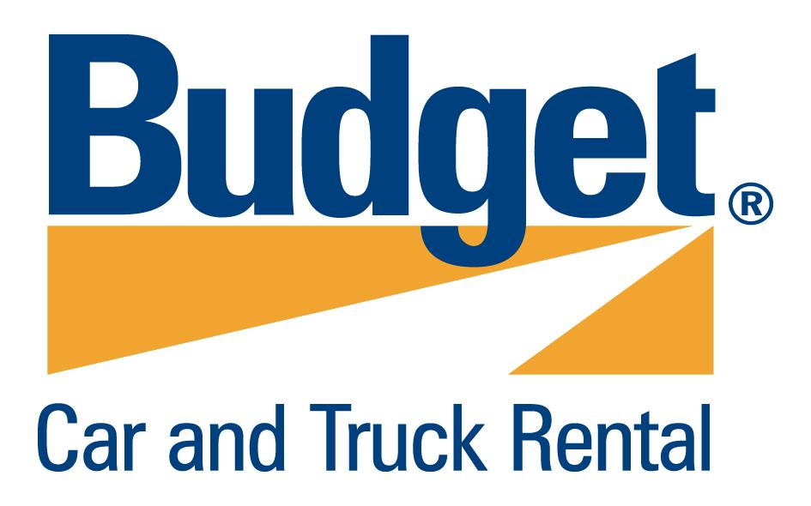
To make your Budget reservation please call Budget Reservations on 1300 305 888 or book
online at www.budget.com.au and quote Budget Customer Discount (BCD) Number D011548

