34TH ANBC INC CHAMPIONSHIP SHOW

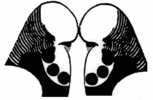
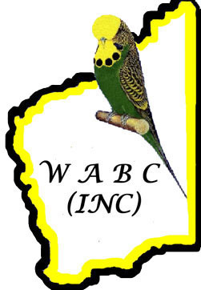
2008 PROGRAMME

FRIDAY 23RD MAY

10.00am to 5.00pm REGISTRATION
2.00pm to 3.00pm ANBC JUDGES ACCREDITATION THEORY EXAMINATION
3.00pm to 5.00pm ANBC JUDGES ACCREDITATION PRACTICAL EXAMINATION
7.00pm OFFICIAL OPENING AND BBQ

Snacks and Drinks available all day at the Venue!

SATURDAY 24TH MAY

8.00am REGISTRATION [Cont]
9.00am to 5.00pm TOUR: Cultural; food and wine tasting.
9.00am JUDGING OF ANBC SHOW [Odd Numbered Classes]
10.00am to 3.00pm VIEWING OF JUDGED BIRDS
10.00am to 3.00pm AUCTION BIRDS ON DISPLAY
12.30pm to 1.30pm CRESTED BUDGERIGAR CLUB OF AUSTRALIA – AGM
2.30pm to 5.30pm ANBC COLOUR & STANDARDS MEETING
3.00pm to 3.45pm GUEST SPEAKER: Janice Al-Nasser
7.30pm DINNER PLUS DJ

Snacks and Drinks available all day at the Venue!

SUNDAY 25TH MAY

9.00am JUDGING OF ANBC SHOW [Even Numbered Classes]
10.00am to 3.00pm VIEWING OF JUDGED BIRDS
10.00am to 2.00pm AUCTION BIRDS ON DISPLAY
12.30pm to 1.30pm CLEARWING LUNCHEON [Invitation Only]
2.00pm to 3.00pm AUCTION
2.30pm to 5.30pm TOUR: Cultural and wine tasting
3.00pm to 6.00pm ANBC JUDGES PANEL MEETING [includes Danish Pied Workshop]
7.30pm PRESENTATION DINNER

Snacks and Drinks available all day at the Venue!

MONDAY 26TH MAY

9.00am to 3.00pm ANBC COUNCIL MEETING
3.00pm to 4.00pm ANBC ZONE MEETING: Host Zone plus 2009 Host Zone [Tasmania]
9.00am to 5.00pm TOUR - OPTION 1: Caves, Cultural and wine tasting.
9.30am to 3.30pm TOUR - OPTION 2: Dolphin Discovery Centre
7.00pm BRASEA FUNCTION [Warren Wilson to organise]

34TH ANBC INC CHAMPIONSHIP SHOW

2008 PROGRAMME/Cont

TUESDAY 27TH MAY

DAYBREAK DEEP SEA FISHING CHARTER
[See Tour Information Sheet and Registration Form for full details].
9.00am to 4.30pm TOUR - OPTION 1: CHEERS
9.30am to 11.00am TOUR - OPTION 2: Busselton Jetty Underwater Observatory
5.30pm to 7.30pm INTERNATIONAL DISCUSSION TEAM headed by Ghalib Al-Nasser
(Secretary of the WBO) and including other notable fanciers from Australia
and overseas
7.30pm BUFFET DINNER

WEDNESDAY 28TH MAY

10.00am to 5.00pm AVIARY VISIT: C&B GEARING STUD



